Russell Strauss & Jiewen Wang

CS 6497

Fall 2019

P1 Exploring 3D Colorspace Models

All relevant code is contained within assets\js\components\scene.js.

Blended Color

CIELAB color space expresses color as three values: L for lightness, a and b for chromaticity. It is designed so that the same amount of numerical change in L/a/b values correspond to same amount of visually perceived range.[1] We can blend two colors by taking their mid-point in Lab color space. Then, the blended color is perceptually equidistant to two input colors.

Input colors are specified in RGB color space. We need to convert them to Lab color space. To perform the transformation, we transform to XYZ color space firstly. It is a linear transformation as following.[2]

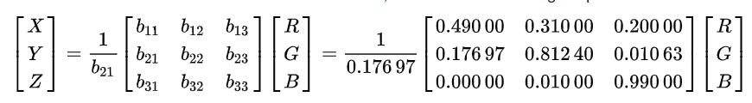

Conversion from XYZ to Lab color space is non-linear.

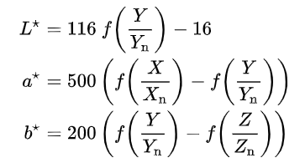

in which 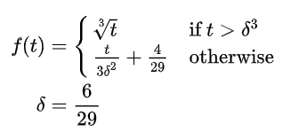

And we choose the parameters as $X_{n}=95.0489, Y_{n}=100, Z_{n}=108.884$

The reverse transformation is

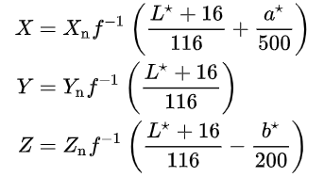

in which 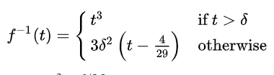

Finally, we convert from XYZ to RGB color space.

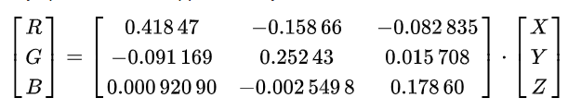

* The formation is invariant when brightness is changed slightly

We change the brightness of a color by multiplying R, G, B values by a certain factor. New values $\left(r^{'}, g^{'}, b^{'}\right)=(sr, sg, sb)$. This transformation is the same as changing exposure in photo editing software like Photoshop.[3]

Brightness change and conversion between RGB and XYZ color space are linear transforms. Given 2 RGB colors $\left(r_{1}, g_{1}, b_{1}\right) (r_{2}, g_{2}, b_{2})$, their midpoint in XYZ space will still be the midpoint when overall brightness is changed. We can show that, in most cases, converting the midpoint in XYZ space to Lab space does not change the midpoint property, even if the conversion is nonlinear.

We start by analyzing function $f(t)$. $t>δ^{3}$ means that $X/X_{n} ,Y/Y_{n} ,Z/Z_{n}$ are greater than 0.0088. The factors $X_{n}, Y_{n}, Z_{n}$ are approximately 100, so $X, Y, Z$ are greater than 0.88. This means $ir+jg+kb$, a linear combination of $(r, g, b)$ is greater than 0.157 by substituting into RGB to XYZ conversion formula. The factors $i, j, k$ are given by three rows of transformation matrix {$b_{mn}$}.

$\left(ir+jg+kb\right)>0.157$ is approximately the same as $(r+g+b)/3>0.157$, given that $\left(i+j+k\right)$ is the summation of each row in matrix {$b_{mn}$}, and it is always 1.

0.157 is a very low value in RGB color space. If $r=g=b=0.157$, the color looks like this C:\Users\wangj\AppData\Local\Temp\1568500796(1).png. Nearly black. We can safely assert that in most situations, especially in natural objects and mixed pigments, R/G/B component of a color is larger than 0.157.

Once we have this condition, $f\left(t\right)=t^{1/3}$ is a homogenous function which means if we multiply each of X/Y/Z component by s, $f\left(st\right)=s^{1/3}f(t)$ (t denotes any of $X/X_{n} ,Y/Y_{n} ,Z/Z_{n}$)

Therefore, after the brightness is changed, new Lab color ${(L}^{'},a^{'},b')$ is

$$\left\{\begin{aligned}L^{'}=116s^{1/3}f\left(Y/Y_{n} \right)-16 \\ a^{'}=500s^{1/3}a \\ b^{'}=200s^{1/3}b\end{aligned}\right.$$

If $\left(L_{3},a_{3},b_{3}\right)$ is the midpoint of $(L_{1},a_{1},b_{1})$ and $(L_{2},a_{2},b_{2})$, the new color with changed brightness $\left({L'}_{3},{a'}_{3},{b'}_{3}\right)$ is still the midpoint of $({L'}_{1},{a'}_{1},{b'}_{1})$ and $({L'}_{2},{a'}_{2},{b'}_{2})$

Background Color

* We want a color that will contrast well with both input colors. To do this, we first get a blend of the two colors by calculating the midpoint of each point in RGB colorspace. This will give us a color that is equidistant in hue from both colors which satisfies the condition that the output color will work equally well with both inputs. Our second condition is that the background color will contrast well. For this, we calculate the complementary color of the blended color. The complementary color is defined as the color opposite on the color wheel. So we can convert our RGB color to HSL so that we can manipulate the hue to find our complementary color. So we rotate the point about the color wheel by Math.PI. Normally the hue value is calculated with degrees or radians, but three.js uses a scale of 0...1. By calculating the linear interpolation from 0...1 to 0...2*Math.PI, we know that the rotation of Math.PI is simply .5, so we perform this transformation on the hue value and then add or subtract a value of 1 from the hue until it is within the range of a single rotation (between 0 and 1).

Accent Color

Triad Color

Dimming exposure

Sources

* <http://paulbourke.net/geometry/rotate/>

1. CIELAB color space, Wikipedia, <https://en.wikipedia.org/wiki/CIELAB_color_space>
2. CIE 1931 color space, Wikipedia, <https://en.wikipedia.org/wiki/CIE_1931_color_space>
3. What is the math behind exposure adjustment on photoshop? Stack Overflow, <https://stackoverflow.com/questions/12166117/what-is-the-math-behind-exposure-adjustment-on-photoshop>